Verification Project

Dr Chris Meudec

Aim
The aim is to familiarise yourself with verification techniques such as Black box Test Case generations, White Box Test Input generations, some fundamental tools used for unit testing, Test Driven Development, applying Object-Oriented design patterns and test coverage measurement.

Setup
As the example will use Java, you must have a Java development environment working on your machine. It should include JUnit5 and a testing coverage measurement tool. If you are unsure which IDE to use, I recommend IntelliJ Community Edition.
This is an individual project.

Grading
This project comprises 3 tasks, and each will count for 25% of your overall mark for this module.

Tasks and Schedule

Task 1
Create Black Box JUnit test cases for the Rate and Period classes based on a specification and methods signatures.
- deadline Friday 27th October at 5 pm
- lab guidance will be provided
- deliverables
  - a unique Google Docs (use this template by making a copy of it via File->Make a Copy) shared with me with editing rights from day one, with under the Task 1 header, details of the rationale for each of your test cases (e.g. the partition targeted by each test input).
  - your corresponding runnable JUnit5 test suite in a Google Drive file shared explicitly with me named exactly SurnameNameTestTask1.java, e.g. MeudecChrisTestTask1.java
- It is your responsibility to ensure that your test file compiles as-is without any modifications:
    - make sure your class name matches the filename;
    - the target code is in a package entitled 'cm' so make sure that you have package cm; at the top of your test file;
    - it is probably a good idea to write dummy Rate and Period classes to make sure your test file compiles (note that I am not asking you to write the actual code for these classes; this is just to make sure your test file compiles);
- 25 marks based on
  - clarity of Google Docs, allowing for the traceability of the test cases generated back to the specification
  - strong evidence of steady progress (constant velocity)
  - quality and regularity of interactions in the lab
  - quality of JUnit test cases
  - respect of guidelines

Task 2
- Deadline Friday 24th November at 5 pm

Task 3
- Deadline Friday 15th December 5 pm

Specification
Here is the specification that was given to the developer. Your job is to test the public methods of the Rate and Period classes.
The system is used to manage various car parks at a given site. There are different kinds of car parks and different kinds of drivers. A partial work-in-progress class diagram is available below.
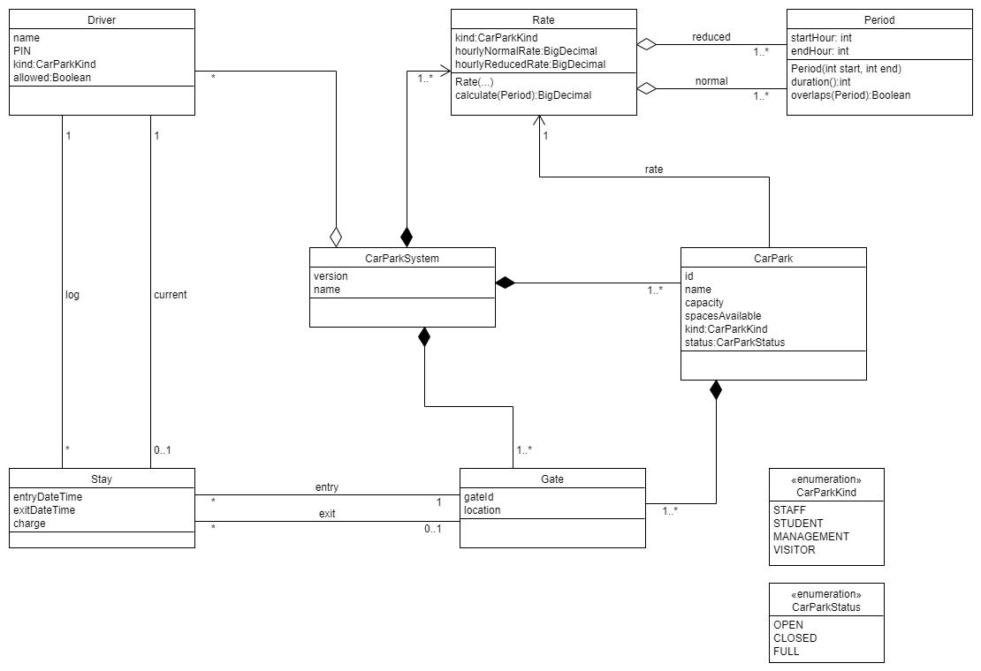
The calculate method returns the charge that a driver has to pay for a stay in a car park of a particular kind. The length of a stay is defined by a Period.
The duration method returns the duration of a stay in hours.
The overlaps method returns true if the passed Period overlaps the current Period.
To allow you to write JUnit test cases, the full signatures of the methods of the Period class are:
public Period(int start, int end);
public boolean overlaps(Period period);
public int duration();
The constraints on a valid Period instance are expressed below using the OCL (section 3 of this tutorial should be all you need to know).
context Period
inv LegalValues: self.startHour >= 0 and self.startHour <= 24 and self.endHour >= 0 and self.endHour <= 24
inv PositiveDuration: self.startHour < self.endHour
A car park stay is calculated in hours, with an hour started counted as a full hour.
Note that a stay by a driver can only be between the hours of midnight (0 hours) and 23:59 (24 hours) as cars are clamped at midnight, and different charging rules apply then.
For accuracy reasons, all charge calculations are performed using the BigDecimal Java class.
A Rate instance comprises a collection of periods when the reduced hourly rate applies and a collection of periods when the normal rate applies.
To allow you to write JUnit test cases, the full signatures of the methods of Rate class are:
public Rate(CarParkKind kind, BigDecimal normalRate, BigDecimal reducedRate, ArrayList<Period> normalPeriods, ArrayList<Period> reducedPeriods);
public BigDecimal calculate(Period periodStay);
Some additional constraints are:
- the normalRate and reducedRate are greater or equal to 0
- the normalRate has to be greater or equal to the reducedRate
- the reducedPeriods and normalPeriods must be valid, i.e.
  - a collection of periods must not overlap
  - the two collections must not overlap themselves
For example, the following reduced periods [(7, 10), (8, 12)] is not valid, whereas [(10, 12), (7, 10)] is fine.
If any of the inputs are invalid, the exception IllegalArgumentException should be raised.
The calculate method returns the charge to be paid according to the number of hours spent in each charge period. The periods not specified are free (e.g. the hours from 0 to 7 are usually free).
For example, if a driver enters at 1:45 am and leaves at 5:23 am, then the period of stay is 1 to 6. If the normal period applies from 2 to 5 and the normal rate is five, and the reduced period applies after that at a rate of 2 then the calculated charge should be 17

